**Project Design Phase-II**

**Data Flow Diagram & User Stories**

|  |  |
| --- | --- |
| Date | 31 January 2025 |
| Team ID | LTVIP2025TMID20276 |
| Project Name | Citizen AI – Intelligent Citizen Engagement Platform |
| Maximum Marks | 4 Marks |

**Data Flow Diagrams:**

A Data Flow Diagram (DFD) is a traditional visual representation of the information flows within a system. A neat and clear DFD can depict the right amount of the system requirement graphically. It shows how data enters and leaves the system, what changes the information, and where data is stored.

**Example:** [**(Simplified)**](https://developer.ibm.com/patterns/visualize-unstructured-text/)

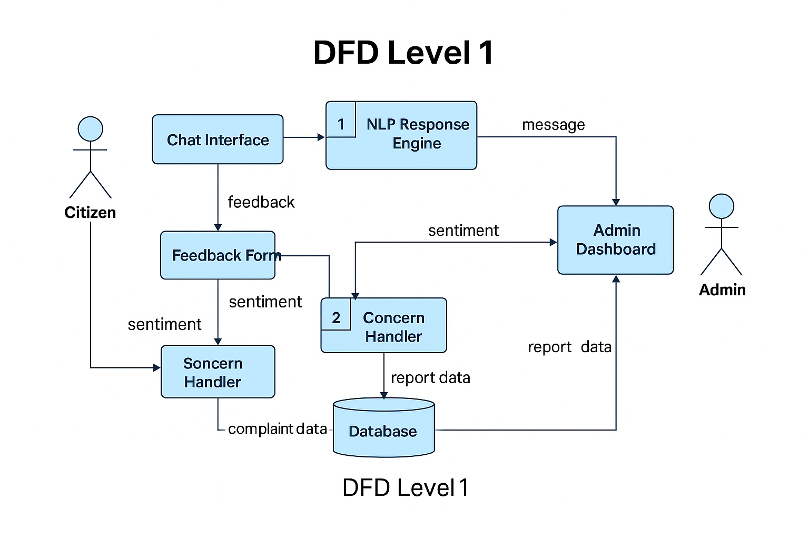

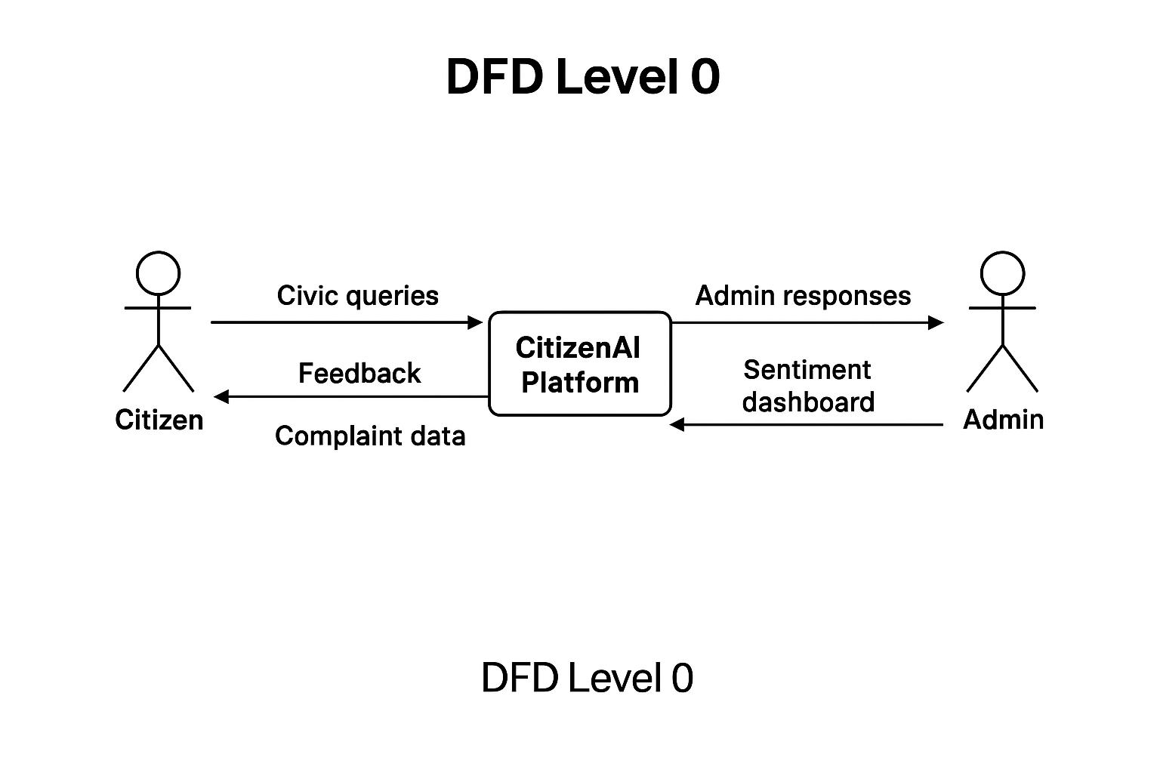

**User Stories**

Organized by user role and mapped with user story IDs, goals, and priorities:

**👤 User Type: Citizen**

|  |  |  |  |  |
| --- | --- | --- | --- | --- |
| **User Story ID** | **User Story / Task** | **Acceptance Criteria** | **Priority** | **Release** |
| US-C1 | As a citizen, I can chat with an AI assistant to ask questions about services or departments. | The bot replies with accurate, prompt answers. | High | Sprint-1 |
| US-C2 | As a citizen, I can submit feedback with a rating or comment. | Feedback is submitted and tagged with sentiment. | High | Sprint-1 |
| US-C3 | As a citizen, I can report civic problems by filling out a form with type, location, and details. | The report is stored and visible in the admin dashboard. | High | Sprint-2 |
| US-C4 | As a citizen, I can chat in my regional language (e.g. Telugu or Hindi). | Multilingual support works correctly. | Low | Sprint-4 (Future) |

**🧑‍💼 User Type: Admin (Municipal Officer)**

|  |  |  |  |  |
| --- | --- | --- | --- | --- |
| **User Story ID** | **User Story / Task** | **Acceptance Criteria** | **Priority** | **Release** |
| US-A1 | As an admin, I can securely log into the system. | Login works only with valid credentials. | Medium | Sprint-2 |
| US-A2 | As an admin, I can view submitted concerns in a list format. | Concern data is filterable by category or date. | High | Sprint-3 |
| US-A3 | As an admin, I can view feedback sentiments in bar/pie chart formats. | Charts reflect live feedback data. | Medium | Sprint-3 |
| US-A4 | As an admin, I get automatic email alerts when certain issues exceed frequency thresholds. | Emails sent to registered addresses on threshold breach. | Low | Sprint-5 (Future) |